Motion W.S.
Non-Accelerated Motion
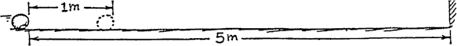
Refer to the following information for the next three questions.

The sketch shows a ball rolling at constant velocity along a level floor. The ball rolls from the first position shown to the second in 1 second. The two positions are 1 meter apart. Discuss and sketch the ball at successive 1-second intervals all the way to the wall (neglect resistance).

- Would the successive ball positions be evenly spaced, farther apart, or closer together?

Why?

- The ball reaches the wall with a speed of m/s and takes a time of seconds.

- The table given below shows data of sprinting speeds of some animals. Make whatever computations are necessary to complete the table.
animal | distance | time | speed
cheetah | 75 m | 3 sec | 25 m/sec
greyhound | 160 m | 10 sec | C
gazelle | 1 km | B | 100 km/hr
turtle | A | 30 sec | 1 cm/sec

A = B = C =
Accelerated Motion
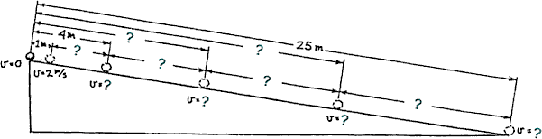
Refer to the following information for the next eight questions.

4. An object, starting from rest, gains a speed v = at when it undergoes uniform acceleration. The distance it covers is d = ½at². Uniform acceleration occurs for a ball rolling down an inclined plane. The plane below is tilted so a ball picks up a speed of 2 m/s each second; then its acceleration a 2 m/s2. The positions of the ball are shown for 1-second intervals. Fill in the blanks for total distance traveled, Δdistance traveled each second, and the final speed at the end of each interval.

cumulative time (seconds) | cumulative distance traveled | Δdistance per second | final speed
0 | 0 meters | --- | 0 m/sec
1 | 1 meter | 1 meter | 2 m/sec
2 | 4 meters | 3 meters | I
3 | D | F | 6 m/sec
4 | E | G | J
5 | 25 meters | H | K
D= ; E= ; F= ; G= ; H= ; I= ; J= ; K=
(Don’t forget the Units)
  - Do you see that the total distance from the starting point increases as the square of the time? This was discovered by Galileo. If the incline were to continue, predict the ball's distance from the starting point for the next 3 seconds.

  - Note the increase of distance between ball positions with time. Do you see an odd-integer pattern (also discovered by Galileo) for this increase? If the incline were to continue, predict the successive distances between ball positions for the next 3 seconds.

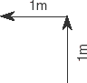
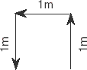
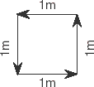
  - Which vector diagram represents the greatest magnitude of displacement for an object?

  - What would be the total displacement of a student who walks 3 blocks east, 2 blocks north, 1 block west, and then 2 blocks south?

  - A group of bike riders took a 4.0 hour trip. During the first 3.0 hours, they traveled a total of 50. kilometers but during the last hour they traveled only 10. kilometers. What was the group's average speed for the entire trip?

13 km/hr | 15 km/hr | 30. km/hr | 40. km/hr

  - Now, suppose a car travels 90. meters due north in 15 seconds. Then the car turns around and travels 40. meters due south in 5.0 seconds. What is the magnitude of the average velocity of the car during this 20.-second interval?

2.5 m/s | 5.0 m/s | 6.5 m/s | 7.0 m/s

  - Which set of terms pairs up an initial vector quantity with its associated scalar quantity?

acceleration and velocity
displacement and distance
speed and time
instantaneous velocity and instantaneous speed

  - A baseball pitcher throws a fastball at 42 meters per second. If the batter is 18 meters from the pitcher, approximately how much time does it take for the ball to reach the batter?

0.43 sec | 0.86 sec | 1.0 sec | 2.3 sec

  - The position of two blocks at successive 0.20 second time intervals are represented by the numbered squares in the diagram below. The blocks are moving toward the right. Do the blocks ever have the same speed?
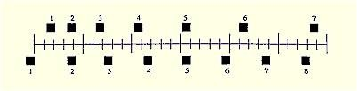

No.
Yes, at exactly 2.
Yes, at exactly 2 and then again at 5.
Yes, some time during interval from 3 to 4.

  - A motorist travels 400 km at 80 km/h and 400 km in at 100 km/h. What is the average speed of the motorist on this trip?

84 km/hr | 89 km/hr | 90 km/hr | 91 km/hr | 95 km/hr

  - A toy car moves 0.80 m in 0.5 s at the constant velocity. If it continues, how far will it travel in a total of 3.0 s?

  - At a uniform speed you travel a distance of 72 cm in a time of 12 seconds. What was your average speed?

  - Your speed is uniform at 45 kilometers per hour. What distance did you travel in 20 minutes?

  - Your speed is uniform at 36 m/min. How much time would be needed to move 9.0 meters?

Refer to the following information for the next two questions.

19. This chart indicates three positions of an object as it traveled at a constant speed.

 | P1 = 0 | t1 = 0
 | P2 = 15 cm | t2 = 5 sec
 | P3 = 30 cm | t3 = 10 sec

- How fast were it traveling at exactly 8.0 seconds?

- Where was the object located at exactly 8.0 seconds?

20. You drive a total of 300 kilometers in 6 hours. What was your average speed?

Refer to the following information for the next two questions.

21. Suppose you were able to drive 300 kilometers in 6 hours at a constant speed.

- How fast were you traveling precisely 4.0 hours into your trip?

- Where were you located precisely 4.0 hours into your trip?

- Your average speed is 76 cm/sec, computed over a distance of 418 cm. How much time was required to travel 418 cm?

- Your average speed is 44 m/sec, computed over a time interval of 0.20 sec . What total distance was traveled during 0.20 seconds?

- You run 100 meters at a speed of 5.0 m/sec and then you walk 100 meters at a speed of 1.0 m/sec. What is your average speed for this entire exercise period?

- You run for 100 seconds at a speed of 5.0 m/sec and then you walk for 100 seconds at a speed of 1.0 m/sec. What is your average speed?

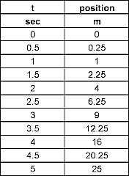
- The following table represents a group’s data for the motion of their ball down a hill.

What was the ball's acceleration?
27. The following table represent a group’s data for the motion of their car down the hallway.
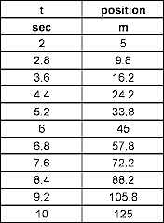
R

What acceleration did the cart experience?

